This Java program is a simple multiple-choice quiz that allows users to answer five questions and receive a score based on their responses.

The program begins by importing java.util.Scanner to handle user input and java.util.concurrent.TimeUnit to introduce a delay for simulating score calculation.

The Main class contains the main method, where a Scanner object is created to read user responses.

Each question is displayed using System.out.println(), and the user’s input is stored in corresponding string variables.

The program then initializes a score variable to zero and uses switch statements to compare the user’s answers against the correct choices, increasing the score accordingly.

After all answers are checked, the program prints "Calculating scores..." and pauses for four seconds using TimeUnit.SECONDS.sleep(4);, creating an illusion of processing.

Once the delay completes, the program displays the user’s score out of five and calculates the percentage using (score / 5.0) * 100 to avoid integer division errors.

I feel this structured approach makes the quiz interactive and engaging while ensuring proper execution and readability.

// Code

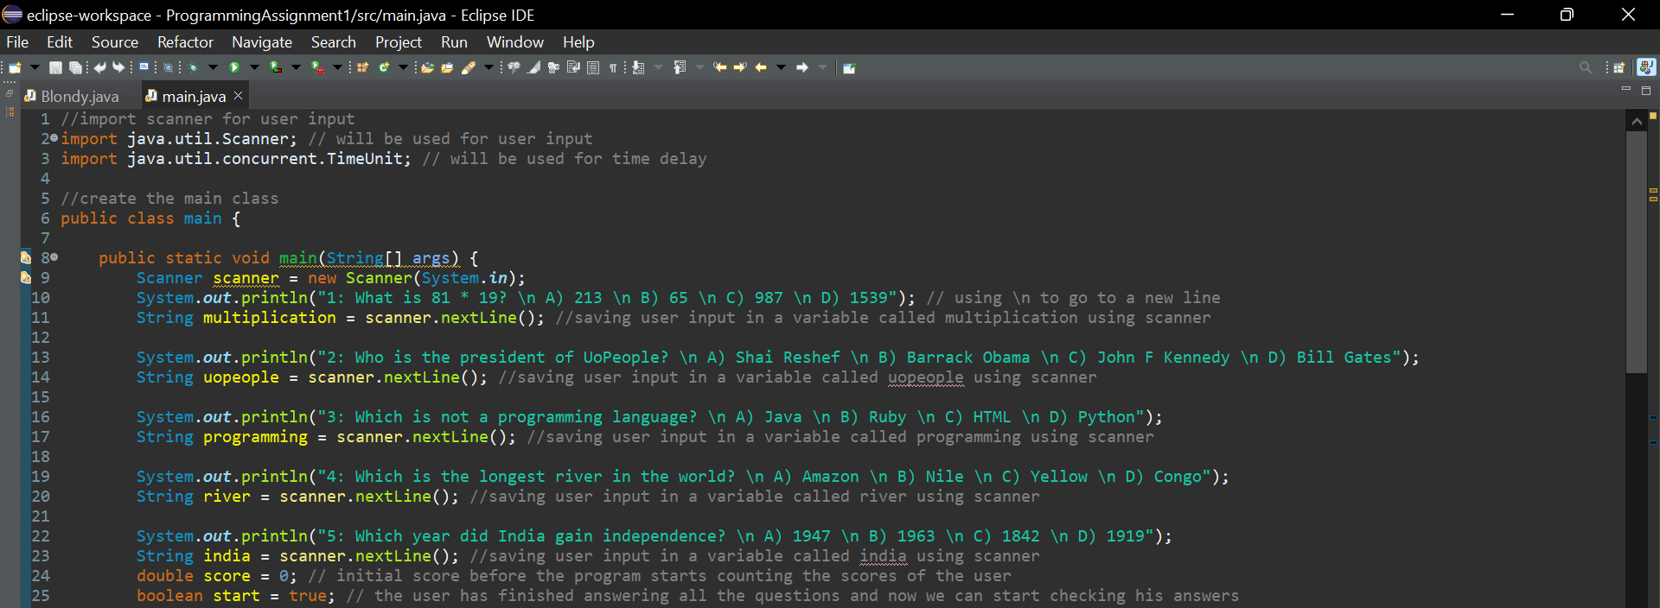

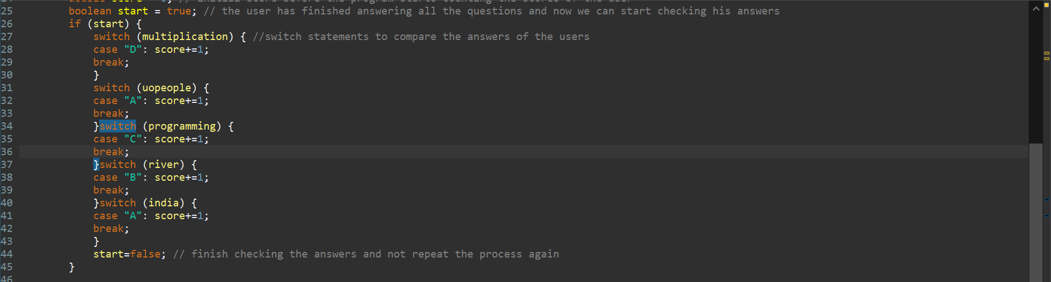

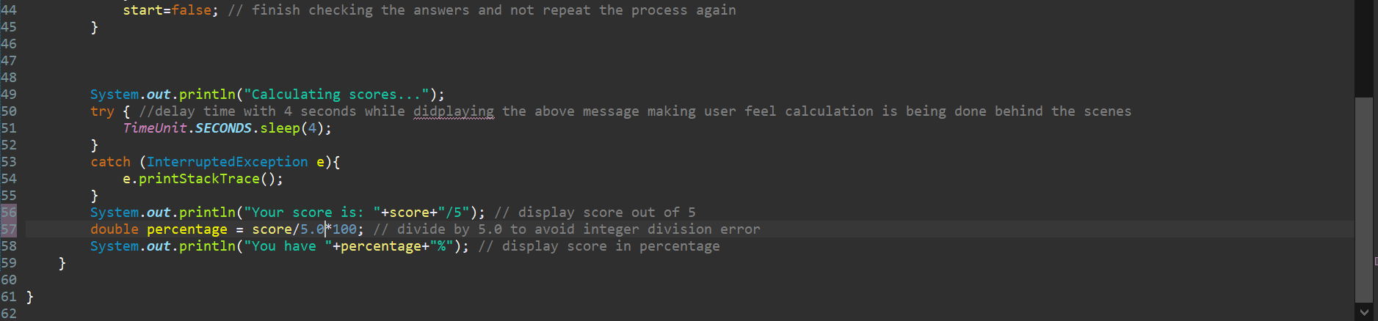

// Example Output



✅ The program **accepts user input**, checks answers using switch, and **calculates the score**.

✅ A **4-second delay** makes it feel like a real quiz system.